handwritten thank you cards (cherish collection) order/quote form

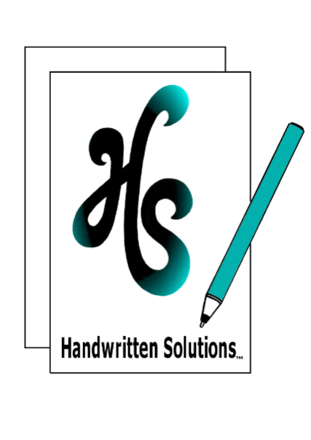
PLEASE EMAIL YOUR COMPLETED FORM sally@handwrittensolutions.com.au
Homework Tips Checklist for Parents
DATE Click or tap to enter a date. NAME Click or tap here to enter text. BUSINESS (IF APPLICABLE) Click or tap here to enter text. POSTAL ADDRESS Click or tap here to enter text. EMAIL Click or tap here to enter text. PHONE Click or tap here to enter text.

I WOULD LIKE TO USE THIS FORM FOR:
☐ an Order ☐ a free, no obligation Quote

cherish collection card code
☐ TYCBCC Quantity Click or tap here to enter text.
☐ TYCBOCC Quantity Click or tap here to enter text.
☐ TYCDCC Quantity Click or tap here to enter text.
☐ TYCN3DCC Quantity Click or tap here to enter text.
☐ TYCNBCC Quantity Click or tap here to enter text.
☐ TYCSWCC Quantity Click or tap here to enter text.

LASER CUT OUTER CODE
☐ LCAW15 ☐ LCBFW15
☐ LCFI15 ☐ LCFP15
☐ LCFR15 ☐ LCFW15
☐ LCLHW15 ☐ LCSHW15

THANK YOU LETTERING COLOUR
☐ BLACK ☐ METALLIC GOLD
☐ METALLIC BRONZE ☐ METALLIC SILVER
☐ METALLIC BLUE

CHOICE OF TAG
☐ KRAFT ☐ WHITE

DO YOU REQUIRE A HANDWRITTEN MESSAGE ON INNER CARD
☐ YES ☐ NO

DO YOU REQUIRE THE ENVELOPE TO BE HANDWRITTEN?
☐ YES ☐ Recipient Name and Address
☐ Recipient & Sender Name and Address
☐ NO

handwriting style (FOR MESSAGE AND/OR ENVELOPE)
☐ ‘EVERYDAY’ (standard by default) ☐ OTHER Click or tap here to enter text.

PEN COLOUR (FOR INSIDE AND/OR ENVELOPE)
☐ BLACK ☐ BLUE
☐ OTHER Click or tap here to enter text.

WHERE would you like your HANDWRITTEN THANK YOU CARD/S TO BE POSTED?
☐ Back to me ☐ To recipients

DATE NEEDED BY (if applicable)
Click or tap to enter a date.

ANY OTHER DETAILS THAT YOU WOULD LIKE TO LET ME KNOW
Click or tap here to enter text.

** AS AN ORDER FORM: I WILL EMAIL YOU AN INVOICE ONCE ALL INFORMATION IS RECEIVED. PLEASE PAY THIS INVOICE AS SOON AS YOU RECEIVE IT SO I CAN GET TO WORK ON YOUR PROJECT. **
** PLEASE ATTACH ANY OTHER RELEVANT INFORMATION SUCH AS WORDING, NAMES, ADDRESSES, ETC, TO YOUR EMAIL **

